Stem cells can be safely infused in brain to promote stroke recovery, study finds
Alexandria Hein Published May 21, 2015

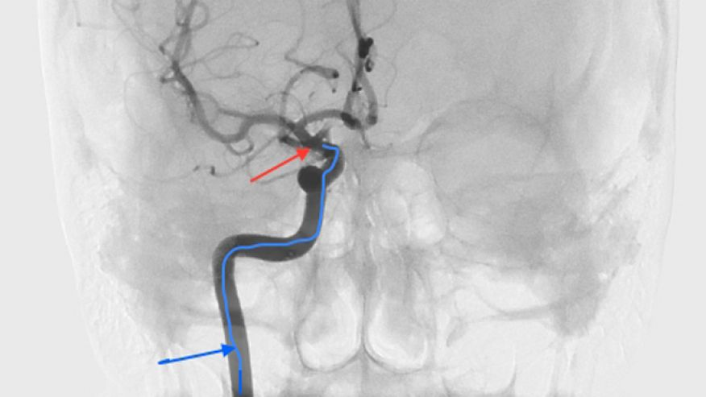
This image looks at the patient’s head from the front, showing where the stem cells are given in the carotid artery. The blue arrow points to the catheter traveling into the carotid artery, and the red arrow points to the tip of the catheter where stem cells are released. (Interdisciplinary Stem Cell Institute)

A yearlong study of stroke patients has found that stem cells from a patient’s bone marrow can be safely infused in the brain through the carotid artery to promote recovery. Researchers at the Interdisciplinary Stem Cell Institute at the University of Miami Miller School of Medicine followed 48 patients, more than half of whom who were treated using stem cells, and found recovery along with no adverse side effects when compared with their counterparts.
“The primary aim of this first U.S. trial of giving stem cells through the carotid artery was really safety: to establish safety beyond a good measure of doubt,” Dr. Dileep Yavagal, associate professor of neurology and neurosurgery at the University of Miami Miller School of Medicine and faculty member at the Interdisciplinary Stem Cell Institute, told FoxNews.com.
“The main concern that needed to be settled was that these cells by themselves could lead to decreased blood flow in the brain because they are live cells and they do occupy some space – a few microns each— and in laboratory studies, the concern had been raised that when you give them directly into the carotid artery, they can cause plugging,” Yavagal, also the director of interventional neurology and co-director of endovascular neurology said. “The study showed that that did not occur.”
In the trial, bone marrow from the patients was taken to an outside facility for about a 48-hour period in which the stem cells were separated and then shipped back to the procedure site to be infused. Of the 48 patients, 29 received the stem cells, while 19 received a placebo. The patients who received the cells were under conscious sedation as the cells were infused through a catheter in the groin area, up to the internal carotid artery in the brain. Each patient received the treatment within an average of 15 days after their stroke. Yavagal said each patient was given a relatively low dose to ensure the safety of the trial.
“The effort in my laboratory for the last six years has been exactly to see how one can avoid these cells clogging the blood vessels, and what we’ve proven now and published is that the dose of the cells is what matters,” Yavagal said. “The side effects are dose dependent, when you lower the dose from what was used in the past, the side effect goes away.”
Each patient was assessed at 24 hours post-procedure and again at 90, 180 and 365 days. Patients also underwent MRI scans one day after infusion, and again six months and one year later. In addition to the procedure, both the placebo group and the treated group of patients were given traditional stroke-recovery therapy. Patients who were given the stem cell treatment were noted to recover motor skills and speech.
Yavagal explained the stem cells act as drug factories in the area of the brain damaged by the stroke, secreting a number of useful substances to promote recovery. The cells help repair damaged cells, including ones that encourage growth and act as anti-inflammatory aids. Some of the properties also act to salvage cells that are on the edge of dying, helping to preserve brain tissue and act as neuroprotectors.
“Previously it was thought that they transform into neurons and brain tissue, but especially with bone marrow cells that does not seem to be the case,” Yavagal said. “The main effect seems to be through the supportive functions or nursing functions.”
Another concern that the study aimed to address, Yavagal said, was that patients may go on to develop brain tumors after the use of stem cells. While none of the 29 patients who were given stem cells were found to have a brain tumor, one of the patients in the placebo group did. Yavagal said the cause for this patient’s tumor was unrelated to the study.
While the study was too small to analyze whether gender, age or time between stroke and stem cell infusion played a role in patients’ recovery, Yavagal said the next step would be to secure funding for a larger study where these factors could be investigated. The group is also looking into using stem cells from the bone marrow of healthy donors as a means to provide a quicker, more available approach.
“We do suspect that there is some time effect based on laboratory data, so giving them earlier use of cells ‘off the shelf’ may have a larger benefit,” Yavagal said.
The team is hopeful that their findings will encourage other researchers to consider their data in looking to use stem cell treatment in other fields of medicine.
“This study opens the door to future clinical trials that will explore new methods of repairing damage to the brain with cell-based therapies,” Dr. Ralph L. Sacco, chairman of neurology at the University of Miami Miller School of Medicine, said in a news release. “Stroke researchers now know that stem cells can be used safely and efficiently without compromising the health of the patient. We have more work to do in this promising area to improve the outcomes of our stroke patients.”
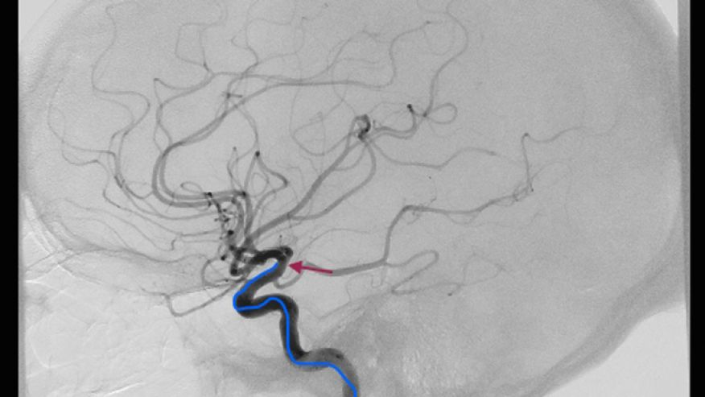
This image shows the patient’s head from the side, indicating where the cells are given in the carotid artery. The blue arrow points to the catheter traveling into the carotid artery, while the red arrow points to the tip of the catheter where stem cells get released. (Interdisciplinary Stem Cell Institute.)

